Per installare su iptv scaricare la lista canali (https://www.radionapoliemme.it/lista.m3u)

Per scaricare l'App ( https://my.radiolink.app/radionapoliemme/index.php) andare su condividi e poi aggiungere alla schermata Home .
Inquadra il QR Code e scarica L’app 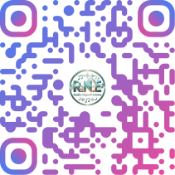

https://rtmp.streams.ovh:1936/radionapoliemme/radionapoliemme/playlist.m3u8

https://rtmp.streams.ovh:8081/radionapoliemme-1/index.m3u8 Tele Saviano

http://nrf1.newradio.it:2000/stream/10404

https://nrf1.newradio.it/stream/97

Player
<div style="position: relative; overflow: hidden; width: 100%;padding-top: 56.25%;">
<iframe width="560" height="300" src="https://rtmp.streams.ovh:2020/VideoPlayer/radionapoliemme?autoplay=1" style="position: absolute;top: 0;left: 0;bottom: 0;right: 0;width: 100%;height: 100%;" scrolling="no" frameborder="0" allow="autoplay" allowfullscreen webkitallowfullscreen mozallowfullscreen oallowfullscreen msallowfullscreen></iframe>
</div>

